*Reference Page While Writing – Delete this page before submission*

Gather this information before submitting

You will provide the following on the Google Form when you submit your article; you do not need to include this in the submission file itself.

Name: As preferred for publication

Author Bio: You will upload this to the Google Form when you submit your piece. two to three sentences are perfect! Please feel free to review other author bios for an example, but generally, you don’t have to be as professional as in school applications but also not something that you don’t want an employer/faculty reading

Author Photo: You will upload this to the Google Form when you submit your piece. Photos recommended to be square ratio (same height and width) to avoid stretching. Only headshot needed -- no need for anything below the shoulders.

Filename for photo: Your first and last name

Social Media: Twitter or Instagram, as you want to share for professional use! We can attach this your author bio, and we can tag you in our sharing of your work in our social media. Plus we would love to connect with you personally!

Our twitter: @InterveneStream
Our Instagram: @InterveneUpstream
Our Facebook: Intervene Upstream

*Reference Page While Writing – Delete this page before submission*

Resources to get article images:
Custom
- Ask your artist friends! Draw, take photos, or graphic design the images yourself
- Request our artist servicesby copying the following on the first line of the submission
Please forward article to design team upon acceptance.

Royalty-Free Image Websites:
https://www.pexels.com/royalty-free-images/ https://unsplash.com/ https://pixabay.com/
https://burst.shopify.com/free-images https://commons.wikimedia.org/wiki/Main_Page

General Guidelines
- Our publication and online writing is not the same as academic writing for a class or professor. We aim to publish thought-provoking and unique pieces which demonstrate your own abilities to reflect. Remember that our medium is online and so important is being able to be readable to our audience online. this isn’t a purely academic publication, and it is a space for graduate public health students -- peers and those interested in reading what we think.
- Please see articles we have published in the past to get a feel for our publication
- All images should include a caption and a citation (link to site and artist)
- Feel free to bold text to highlight certain information.
- References should be footnotes (not endnotes) with citations in Associated Press or APA style. Do NOT utilize in-line citations (like this).
- Utilize subheadings. Online readers often skim over headlines to find information which catches their eye; here is a good reference: https://idratherbewriting.com/2013/08/23/subheadings-perhaps-the-most-useful-technique-in-technical-writing/
- In general, write with active voice.
- Utilize the free version of Grammarly.com (but don’t automatically accept every suggestion – they are wrong sometimes) to standardize some copy-editing and to catch common errors.

If your submission is not written work:

Video, photography, illustrations, music, and other mixed media pieces (i.e. not a .doc, .docx or similar) must be mailed to the Editor-in-Chief directly at editor-in-chief@interveneupstream.org alongisde a document containing your author info and submission info (as indicated above)

Intervene Upstream Submission: Page 1 (Delete this line)

Title: this will be what grabs your audience attention, so make sure to make it pop or something that someone with an interest in that topic will find relevant

Keywords: at least five “tags” (think hash tags) that can be associated with your piece

Links/Citations to All Images Included: The images must be in the commons, royalty-free, open-license, photos you’ve taken, etc. Make sure you list the link or citation to each image you use. see ‘Images’ section in the following section

INSERT BODY OF PIECE HERE

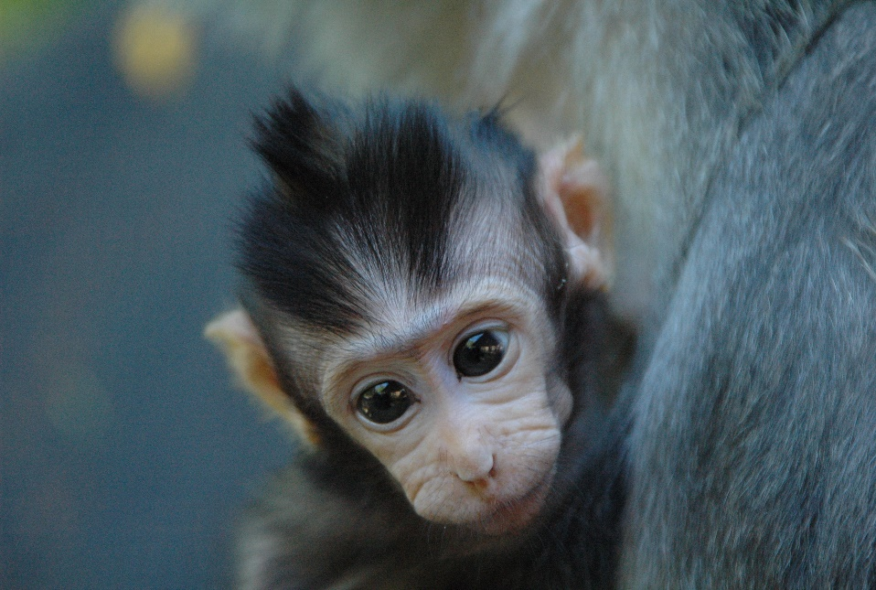
Figure 1 A baby monkey by Unknown Author is licensed under CC BY-SA (from Wiki Creative Commons)

Footnote example!

